Name :Spogmai jan
Roll no:2430 – 0081
Course: Artificial intelligence
Submitted to :Zeeshan Ahmed
Date of submission:08/03/2026

Assisngment # 01
Question :01
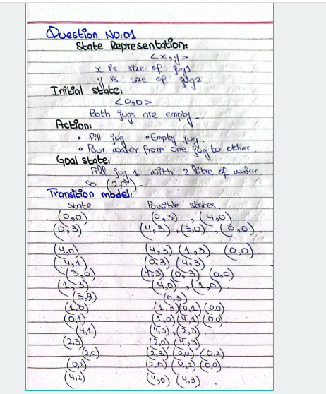

Question :02
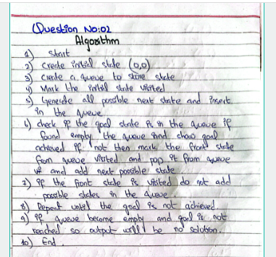

Question :03
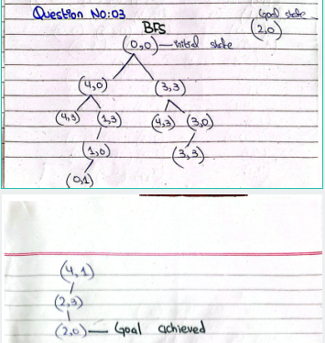
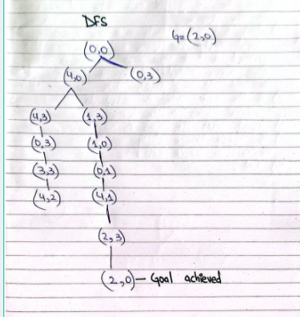

Question :04




